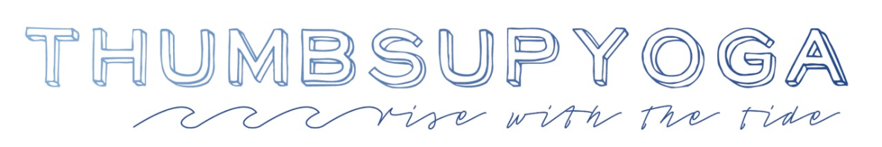

The ThumbSUP Yoga Teacher Training Immersion Program is designed for teachers and students to learn the fundamentals of how to teach yoga on a paddle board. The immersion may come in the format of a ½ day to full day workshop. It's an intro to teaching yoga on a paddle board or an enhancement to education as a teacher and/or practitioner. It's often included as part of a 200/300/500hour or Master Class programming or as a one-off workshop for the sport's growing popularity, for the complement to yoga philosophy study and for the support that yoga on a paddle board contributes to anatomical and biomechanical understanding.
Topics include:
- Equipment
- Preparations
- Timeline of a ThumbSUP Class
- Welcome / Suit Up and How Tos
- Sequencing / Balance / Theming
- Disembarkment and Business Development
An immersion does not include:
- ThumbSUP Yoga Certification
- A Water Rescue Accreditation
- Pre-requisite of First Aid and CPR
FAQs
Can I teach SUP Yoga upon completion of the immersion? We highly recommend that you teach a SUP Yoga class with the assistance of a certified water safety professional (life guard trained or equivalent). Most surf shops / SUP Lesson outfits in our neck of the woods will require such, even if the "floating yoga studio" is right next to the shore.
Why would I want to add a ThumbSUP Yoga Teacher Training Immersion Program to my Yoga Studies? Perhaps you are the curious type, you plow towards an adventure, and/or have a draw to the sea / great outdoors for the peace that is promoted with time spent amongst the elements. Perhaps you wonder how challenging balance can inform your studio classes and teaching. Or perhaps you have a thing for an early evening light show, glimmering though clouds. I can relate.
Do I have to be a Yoga Teacher to take this immersion? No. If you want to teach SUP Yoga on a Paddle Board you should be an existing yoga teacher or training to become a yoga teacher but taking this immersion is also for the student looking to deepen his/her yoga practice by putting it to float. This immersion will be useful for anyone, regardless of their yoga or paddle board experience.
Do I have to have Stand Up Paddle Board experience to take this immersion? No. The immersion will include the ins and outs of how to sit, stand and paddle. Paddle turns and stroke precision will also be broken down and practiced.
Why should I add a ThumbSUP Yoga Teacher Training Immersion into our existing 200/300/500hr TT programing? Because Yoga on a Paddle Board may inform the biomechanics of yoga postures as intrinsic, stabilizer muscles are recruited for balance and foundation. It will support your land lessons while highlighting the importance of continued curiosity and self-study (svadhyaya), foundations as the focal of balance (as below, so is above), the art of letting go (aparigraha), etc. etc. etc.
Ok, I'm IN! How do I schedule a ThumbSUP Yoga Teacher Training Immersion? Contact danielle@thumsupyoga.com. She is looking forward to discussing this with you.

