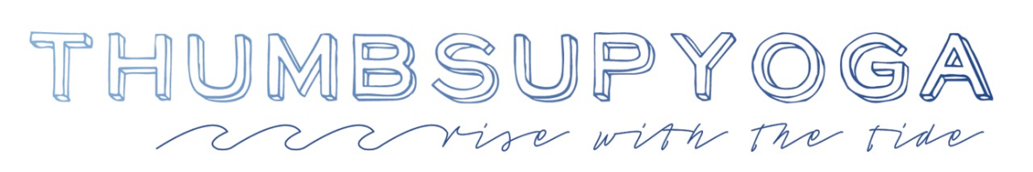

The ThumbSUP Yoga Teacher Training Certification Program is designed to fully prepare teachers to effectively, confidently and safely teach yoga on a stand up paddle board. The certification program frequently consists of two full days of on-board and classroom/dockside lessons and practice. It may be part of a 200/300/500hour or Master Class Yoga Teacher Training programming for the sport's growing popularity, for the complement to yoga philosophy study and for the support that yoga on a paddle board contributes to anatomical and biomechanical understanding. Or, it may be offered as a one-off training in a private or group setting.
Topics include:
- Equipment & Function
- Paddle Strokes Precision
- Preparations & Executions
- Safety Awareness & Response Tools
- Timeline of a ThumbSUP Class including Three unique sequences for Foundation, Flow and Flight classes
- The Arch of Balance Play
- Common Themes with Corresponding Postural & Energetic Alignments
- Nuances of Specialized Classes like Mini&Me and Teens
- Business Development & Access to Continued Coaching
- ThumbSUP Yoga Certification
An immersion does not include:
- A Water Rescue Accreditation (we recommend ASI Water Rescue Course or the American Red Cross Life Guard training)
- CPR & First Aid
FAQs
Can I teach SUP Yoga upon completion of the immersion? We highly recommend that you teach a SUP Yoga class with the assistance of a certified water safety professional (life guard trained or equivalent) until you achieve your Water Rescue Accreditation, CPR and First Aid certificates. (Most surf shops / SUP Lesson outfits in our neck of the woods will require such, even if the "floating yoga studio" is right next to the shore.)
Why do I want to become a SUP Yoga Teacher? Perhaps you've taken some paddle board yoga classes or been out on your own and had a deep feeling like it was all very familiar, like being home. Perhaps you are looking to expand your education with this training and buff your tool-set because you know that the lessons applied on board will radiate to teachings and practice on land. Perhaps you enjoy being outside and want to share your love of nature with others and perhaps in turn, guide them to find thrill and comfort and unanchored joy bundled in a wondrous outdoor playscape.
Do I have to be a Yoga Teacher to take this Training? No. If you want to teach SUP Yoga on a Paddle Board you should be an existing yoga teacher or training to become a yoga teacher but taking this certification is also for the student looking to deepen his/her yoga practice by putting it to float. This certification will be useful for anyone, regardless of their yoga or paddle board experience.
Do I have to have Stand Up Paddle Board experience to take this training? No. The training will include the ins and outs of how to sit, stand and paddle. Paddle turns and stroke precision will also be broken down and practiced.
Why should I add a ThumbSUP Yoga Certification into our existing 200/300/500hr TT programing? Because Yoga on a Paddle Board may inform the biomechanics of yoga postures as intrinsic, stabilizer muscles are recruited for balance. It will support your land lessons while highlighting the importance of continued curiosity and self-study (svadhyaya), foundations as the keystone (as below, so is above), the art of letting go (aparigraha), etc. etc. etc.
Ok, I'm IN! How do I participate in the next ThumbSUP Yoga Certification? Contact danielle@thumsupyoga.com. She is looking forward to discussing this with you.

